Quarterly Seminars – Health & Wellness
Chinese Gong-Fu Institute, Chicago, IL
Date: May 19th, 2013

Location: Chinese Gung-Fu Institute
4614 N. Western Ave., Chicago IL
(773-728-8682) – Web: http://zhangtaiji.com
email: masterzhang@zhangtaiji.com

Seminar 1 - Time: 1:00-2:00
Seminar 2 – Time: 2:15-3:15

Cost: $45 (both seminars, $75)

Seminar 1
Mawangdui Daoyin Exercise
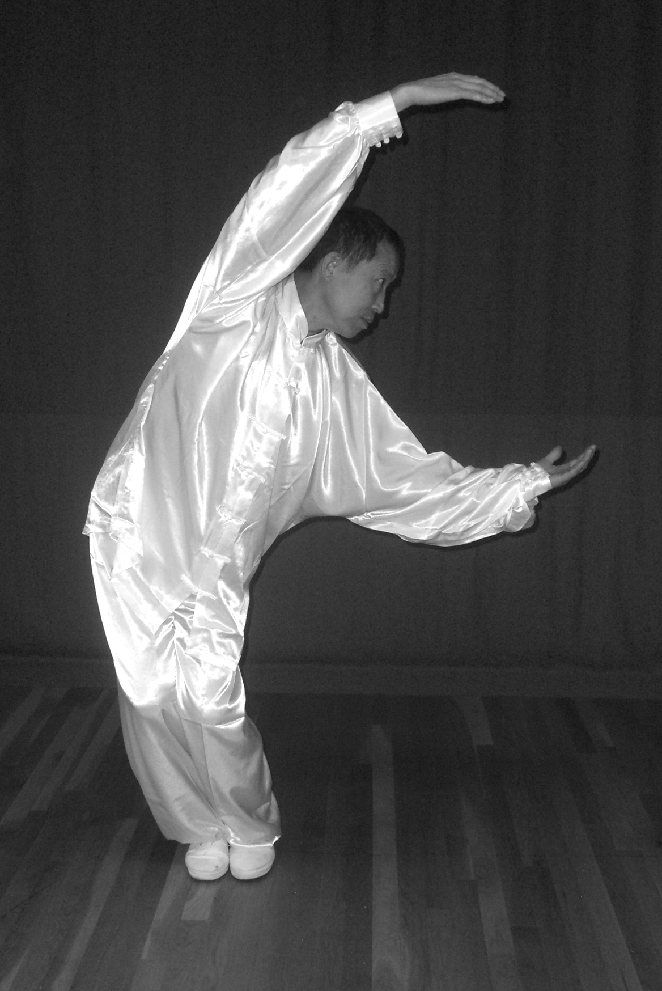
Pictures of Daoyin (energy/Qi circulation) exercises were unearthed in the 1970s in the Mawangdui Tombs of the Han Dynasty (206 BCE-220 CE) in Changsha, Hunan Province, China. These pictures serve as the source of this exercise. The Chinese Health Qigong Association researched, evaluated and compiled the discovered exercises. In Mawangdui Daoyin the mind and body are linked and coordinated, and awareness is increased. The exercise incorporates: rising and squatting, extending and withdrawing, bending and stretching, opening and closing, ascending and descending, rotating and revolving. These simple, beautiful movements are easy to learn and benefit a person physically (outside) and spiritually (inside). They are intended to increase one’s sense of well-being, prevent disease and prolong life.

Seminar 2
Taijiquan
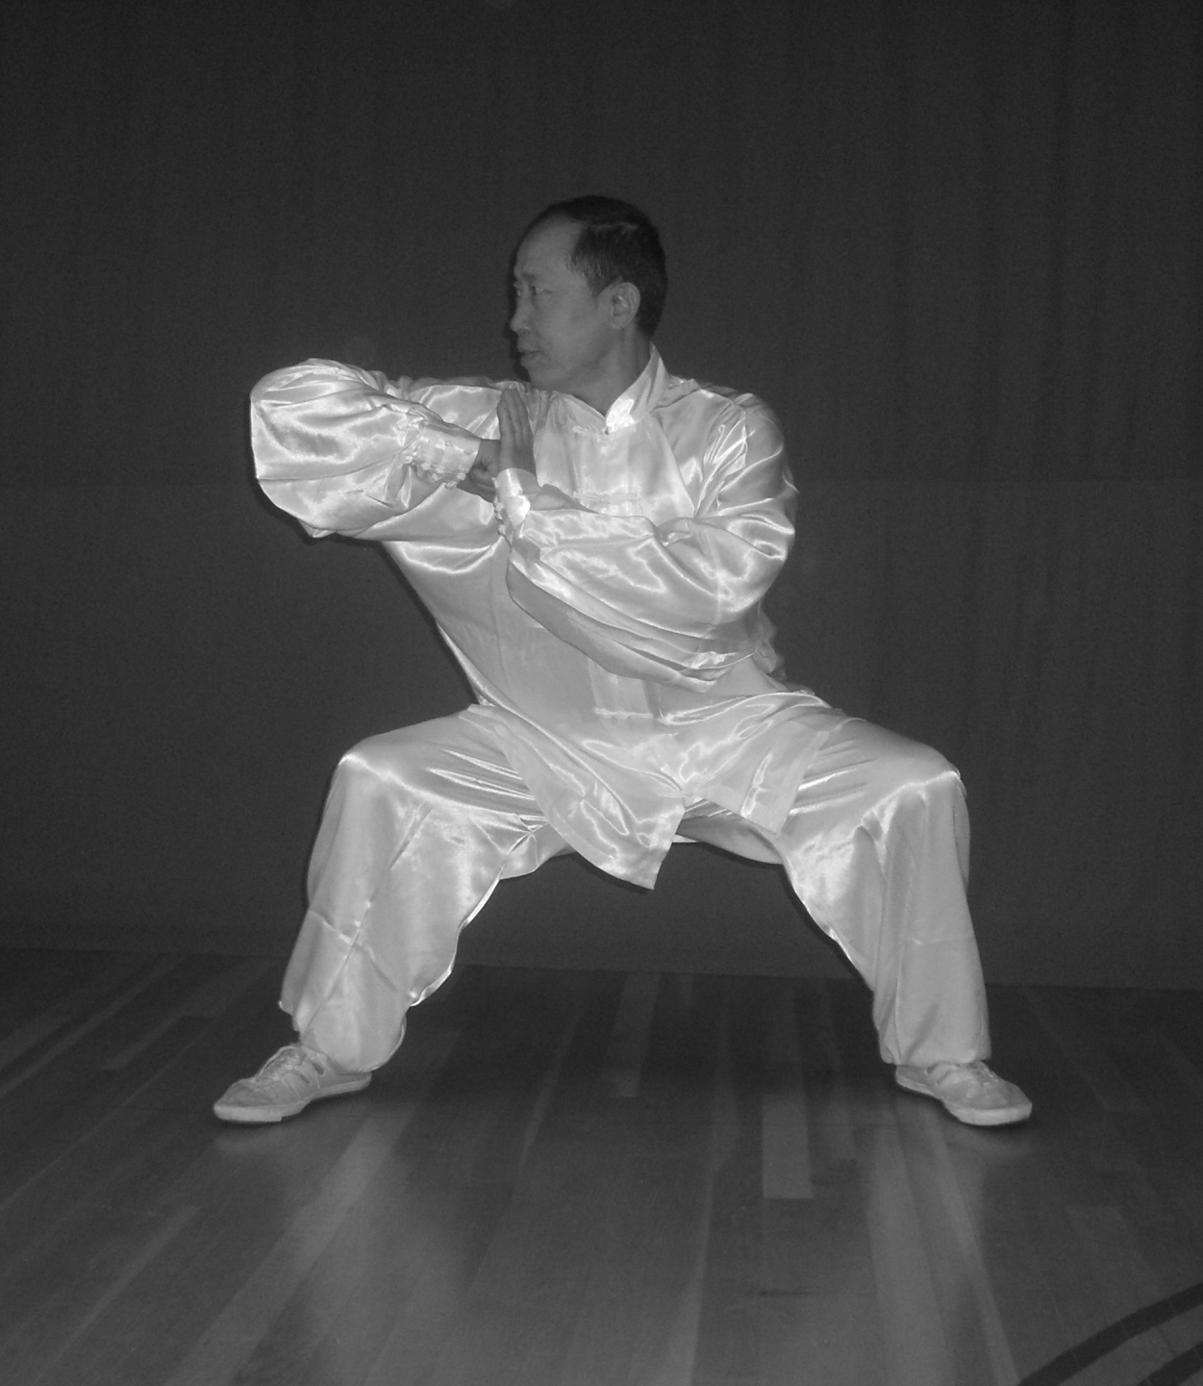
Taiji (Tai Chi) is a well-known, and often-practiced, form of Chinese exercise for health. At this seminar, the Taiji 13 Form will be explored. The 13 Form addresses the 13 basic movements of Taiji – the 8 postures (ward off, roll back, press, push, pull down, split, elbow, shoulder-hip-back strike) and 5 directions (forward, back, left, right, center). This exercise is appropriate for all ages and levels. Those at more advanced levels, in addition to learning the form, will be able to learn refinements in the execution of the specific movements within the form.

About the Instructor

Master Zhang holds Bachelors and Graduate degrees in Gong Fu from the Wuhan Institute of Physical Education and the Shanghai Institute of Physical Education. He has taught Qigong, Taijiquan and Gongfu extensively in China and the United States, and has published on these subjects. He is a multiple Gold Medalist, and a renowned judge at national and international competitions. He is also an expert in Chinese medicine, acupuncture, tuina (massage), and sports injury treatment. He teaches in Chicago, IL. Questions? Call: 773 728-8682
Upcoming Seminars
August 11th
November 10th

Registration Form
Health & Wellness Seminars
Chinese Gong-Fu Institute

Name _______________________________________________________

Phone: _____________________________________________________

Email: ______________________________________________________

I plan to attend:

Seminar 1 – Mawangdui Daoyin _____

Seminar 2 – Taiji 13 Form _____

Please enclose Seminar Fee. One Seminar - $45, Two Seminars - $75.
Day of Seminar Cost: One Seminar - $50, Two Seminars - $80.
Cash only day of seminar.
Please return Registration by May 15th.

Registration should be mailed to: Master Hongchao Zhang, Chinese Gung-Fu Institute,
4614 N. Western Ave., Chicago IL 60625
Make checks payable to Master Hongchao Zhang.

Please Sign Waiver:

I, ________________________, the undersigned applicant, voluntarily chose to attend an event/seminar at the Chinese Gong Fu Institute. I hereby assume the risk and full responsibility for any and all damages, injuries, or losses that I may sustain or incur while attending and/or participating in the Event. I agree and understand that my participation and/or competition in the event/seminar is completely voluntary, and that I must report any and all injuries immediately to the event/seminar staff. I further agree to indemnify and save and hold harmless said Releasees and each of them for any loss, liability, damage, or cost they may incur due to my participating or competing in the Event and whether caused by the negligence or gross negligence of said Releasees or otherwise.

I HAVE READ AND FULLY UNDERSTAND THE WAIVER LISTED ABOVE.

Print Name _______________________________

Signature____________________________________Date __________________________
If competitor is under 18, this form must be signed by parent or legal Guardian.

